# Project Design Document

**Name:** Matthew Sloyan

**ID:** G00348036

**Email:** G00348036@gmit.ie

## My Application:

I have decided to develop and design a “Find by Ingredients” Recipe Application. Its main feature would allow the user to enter a list of ingredients. Then the application would then return a list of the most suitable recipes that included all or some of the ingredients entered, which the user could click/tap on for more details to make the recipe. Other features would include the ability for the user to search a specific recipe just in case they knew what they were looking for, search by image (described below), change the settings, and access their favourite recipes saved in the application (Local storage).

## Initial ideas & thoughts:

Before I started, I looked up the Xamarin Docs to see what was achievable with the framework and where to go with it. I also researched various ideas and thoughts I had using the internet and the Google Play Store to see what was out there. I went through many ideas such as a fitness tracker, college planner and medication reminder but they were not resonating with me, so I thought of the things I enjoy doing which included cooking and eating healthy, so I decided to explore that a little more.

## Why I choose this application:

With that in mind I researched other apps and found loads of recipe related apps, but they could only search for recipes by name which is great, but what if you don’t know what you wanted to make, and only knew what ingredients you had. I wanted to solve this problem as it would be handy for my own life and useful as a business proposal. Based on this, I thought an API would be best suited as it would allow the user to access thousands of recipes easily at their fingertips. I also decided to use API’s as I’ve worked with them before and I wanted to learn more. I began to research various API’s and found a suitable one called “Recipe - Food – Nutrition” by spoonacular (linked in references), which allows access to 365,000 recipes and 86,000 food products. It also allows for natural language queries for all kinds of inputs. With this knowledge I decided to go ahead with developing my ideas for a Find by Ingredients Application.

## Goals:

* At its core I want this application to be as simple as possible but powerful in terms of the number of recipes available to the user.
* I wanted to make the process easy for all types of users by cutting down user inputs and clutter.
* I wanted to learn new technologies such as image recognition software (Google Cloud Vision API). Described in “UI Design & Description/Search by Picture”.
* A clean, professional and aesthetically pleasing design.

## UI Design & Description:

Below you’ll find a drawings (under each section), notes and a descriptions for each page of the application which outlines the user experience, technologies used and how it works.

### Home Page:

On this page the user will be greeted with the most useful features such as some of their favourite recipes, trending recipes and large buttons to quickly access the other pages listed below. I wanted to keep this page as user-friendly as possible. E.g. if the user was preparing food in the kitchen, they wouldn’t have much time, so this app allows the user to quickly search a recipe by ingredients they have, by the name of the recipe or by taking a picture of the ingredients on front of them. All this is done within a few clicks. Also, I have placed the menu buttons at the bottom of the screen to be easily accessible when using one handed.

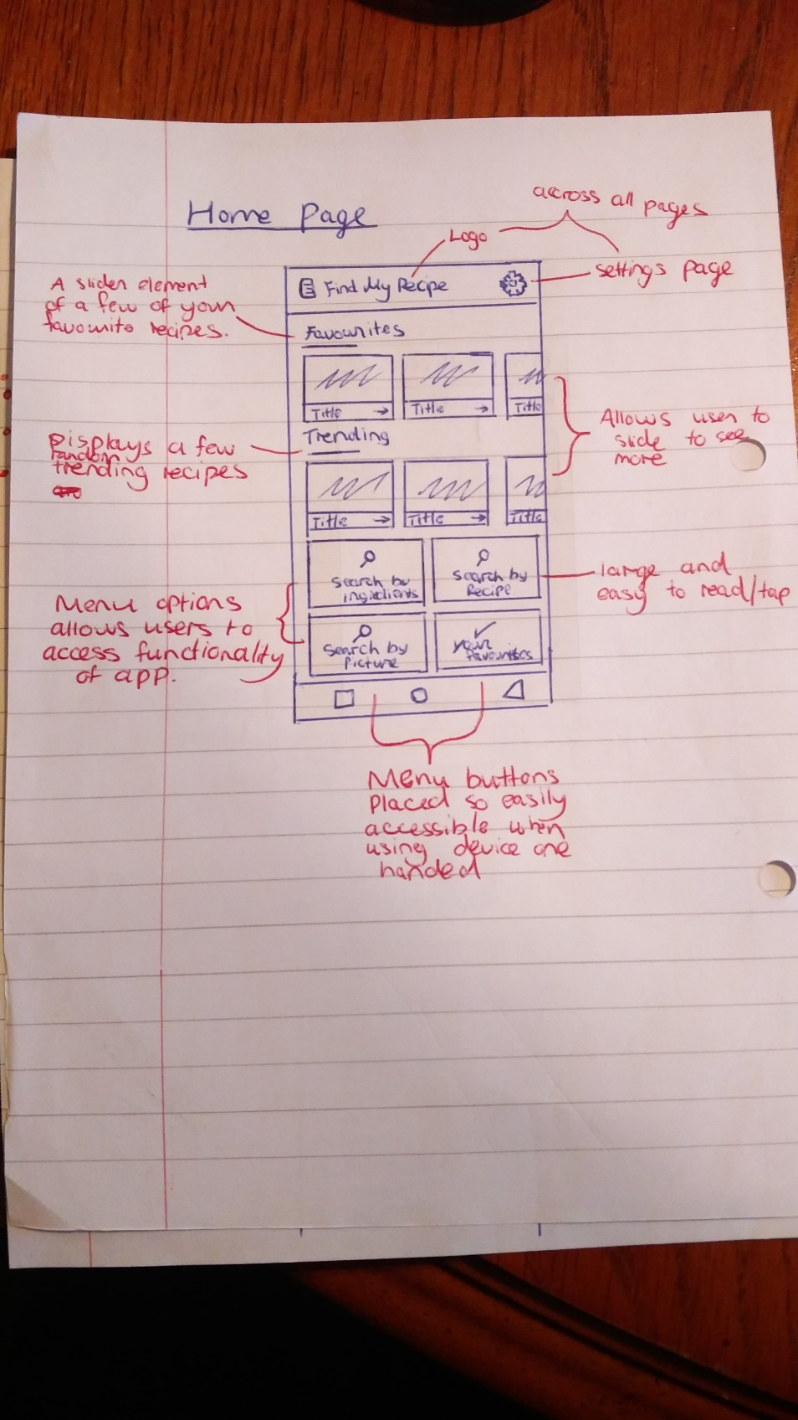

Home Page Sketch

### Search by Ingredients:

An input box is presented that allows the user to input their ingredient via the keyboard. To the right of this is a button to add another ingredient (placed for ease of use), and below the ingredient list is the search button which searches based on the amount of ingredients entered. The buttons are laid out to ensure they aren’t covered by the mobile keyboard, so the user doesn’t have to annoyingly close it just to press the search button. If the search is successful using a HTTP get request, they will be brought a page where a list of recipes will be displayed in columns and rows. Each recipe will contain a picture, title etc. Also, it will include whether all the ingredients are present or how many are missing. If the user clicks on a specific recipe, they will be brought to the page which includes the recipe information (Described in detail below).

### Recipe Page:

This Page will be accessible from many areas of the app and will be dynamically created depending on the specific recipe for code reusability. Below is some of the information that will be displayed for the user in a simple, clean and professional manner. Each element is laid out with usability in mind, E.g. the essentials are first to ensure the user can make the recipe before they spend time looking at the instructions.

* Image of food & options to add to favourites
* If vegetarian, vegan, gluten free icons
* Number of Servings & Serving time
* List of Ingredients
* Instructions

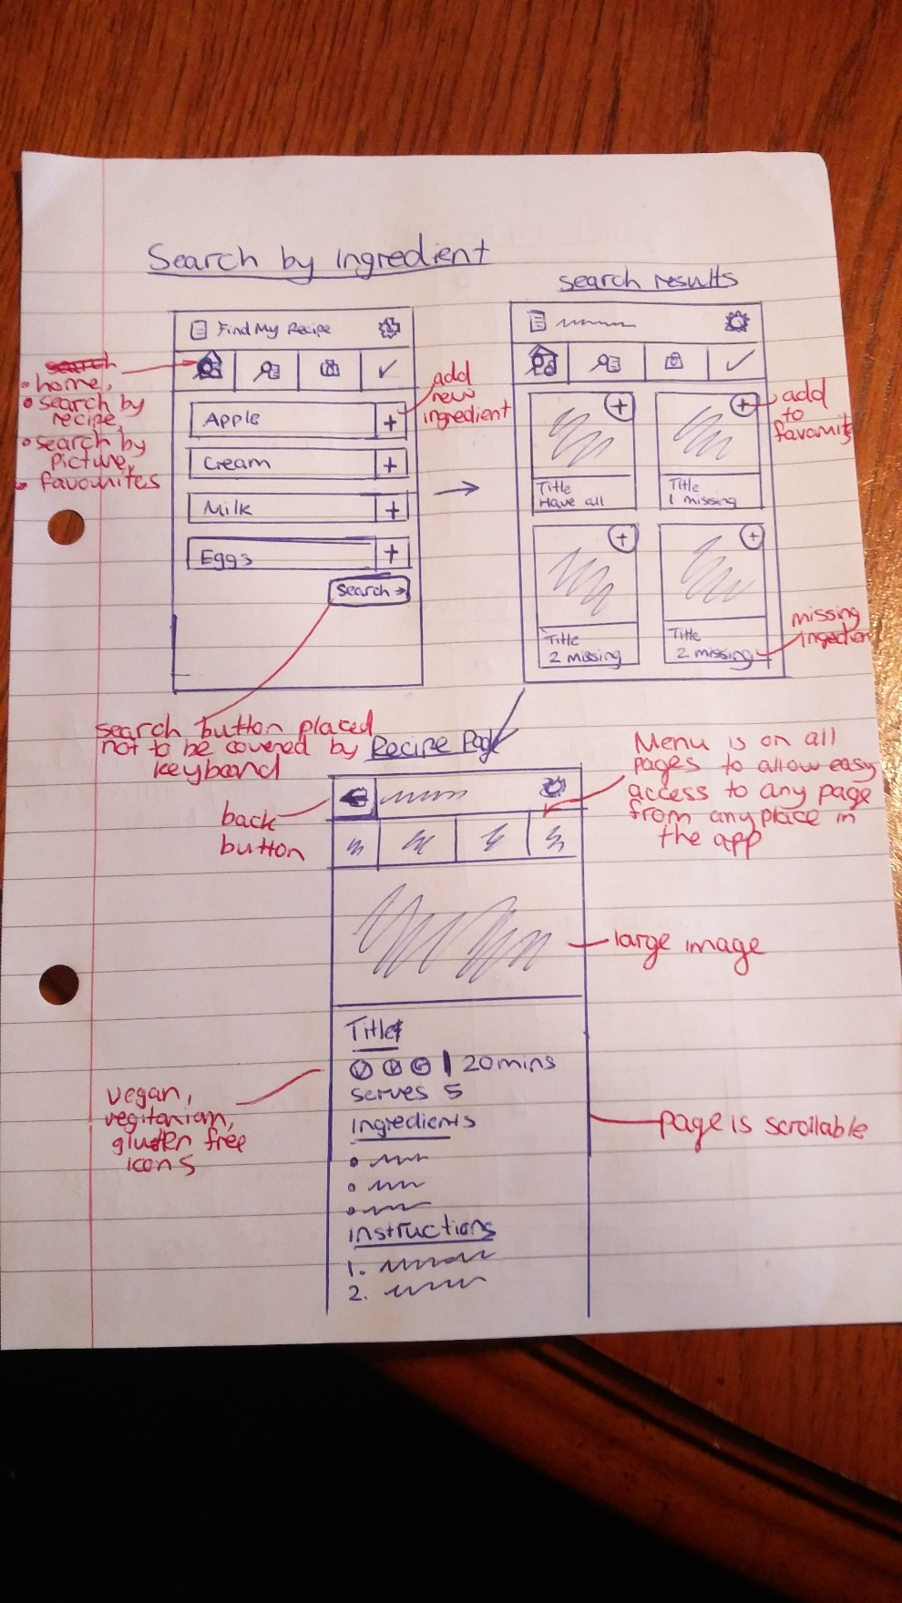

Search by Ingredients & Recipe Page Sketches

### Search by Recipe:

If clicked like above the user will be given a search bar to enter their recipe, which will then load the results below in the same style as “Search by Ingredients”. Again, it uses a HTTP get request to receive this data from the server.

### Search by Picture:

If this menu option is clicked there is a button to take a picture, which will open the platform specific camera and allow the user to take a take a photo. This feature will use Google Cloud Vision API, which uses image recognition software to find what’s in the picture. From early tests it works well but the items need to be clear and separated possibly on the counter, so some instructions will need to be listed to ensure good results. When you send the API an image it returns a list of the most suitable items found.

### Your Favourites:

A list of the users’ favourite recipes is saved here, which will be added from all the various pages. The recipes will be stored as JSON data locally avoiding the need for the user to have a login or access a database. The user can click on each recipe to see more or delete them from the list.

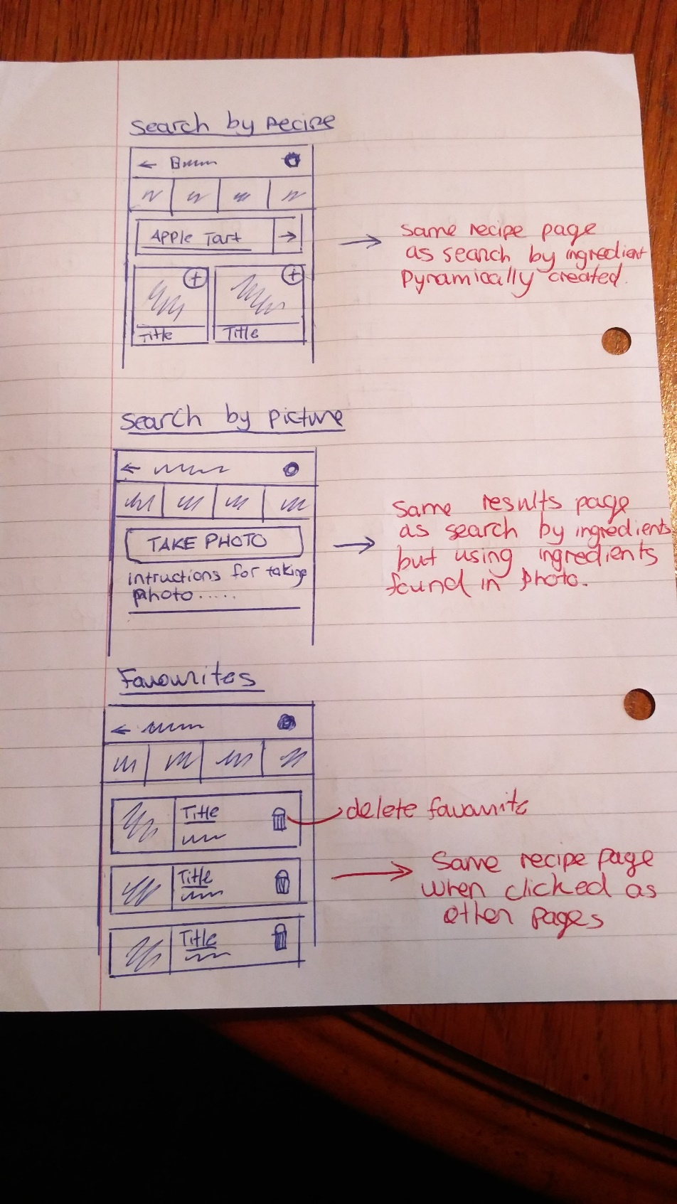

Search by Recipe, Picture and Favourites Pages

### Settings:

Allows the user to change various settings about the app, like for example the number of recipes returned from searches (5, 10, 15), colours, sounds etc. Which will all use local storage to save across the application.

### Additional Notes:

Regarding the menu at the top of all pages (except the home page), I wanted the user to be able to quickly access any page on the application without going back through pages or opening a slide out menu which is found in a lot of apps I researched.

## References:

**API’s**

* https://rapidapi.com/spoonacular/api/recipe-food-nutrition
* https://cloud.google.com/vision/